DS 413/613 Classwork/Lab Web Scraping

Email an Rmarkdown File and a Word File that shows all required code and output.

**1** Using the following link , <https://www.imdb.com/best-of/highest-rated-movies-of-2019/ls091392448/> , show and use R code and the Web Scraping methods illustrated in class to collect data on the top 20 movies of 2019. The first five rows of the data table to be produced are given below. Do not forget to use Chrome and Selector Gadget.

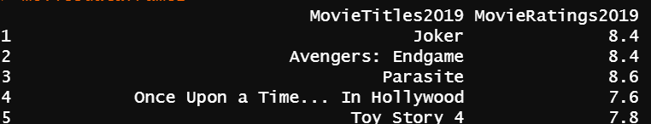

**2** Use and show R code that will produce the following summary values for the variable MovieRatings2019:

a) Minimum b) Maximum c) Q1 d) Median e) Q3 f) Mean

g) Use and show R code to produce a boxplot for the variable MovieRatings2019

**3** a) Using the link provided in your notes, secure a Census Bureau API key. Run the census code that requires usage of the API key and then use R coding to produce a table that shows the median age for households by state for the year 2000.

b) Show and use R code to find the mean, median, ,max, min, Q1, and Q3 for the median age.

**4** a) Using the link provided in your notes, use and show R coding to produce a table that shows the median age for Hispanic or Latino men for the year 2010 (Hint: the 8 character variable code starts with characters P013. Search in your table to get the other four characters.

b) Show and use R code to find the mean, median, ,max, min, Q1, and Q3 for the median age.

c) Produce a coding chunk using dplyr functions to generate a table that gives results for values that are greater than or equal to 25.